Unit 20

Do Loops

Introduction to Do Loops

Overview

Report Designer rules can be used to set up Do Control Structures. A Do Control structure can be used in order to access fields that your report does not have direct access to by looping on a data record or index. In this Unit the following topics will be covered:

- Do Loop Definition
- Types of Do Loops
- Data Structures to Loop On
- Uses for Do Loops
- Setting Up a Do Loop
- Working With Lists
- Looping on Indexes

What is a Do Loop:

Do Loop

A Do control structure uses a looping expression as it's condition. While the
condition is true, the associated statement will be executed. The condition will remain true as long as the looping expression returns a value. The loop will end when the condition is false (i.e. returns a nil value). Let's compare a Do control structure to another control structure we have learned about already, an If control structure:
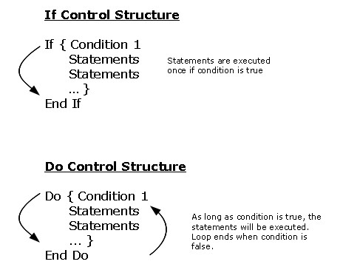
Types of Do Loops:

There are two types of loops that we will work with in Report Designer:

- Looping on data structures – Records or Indexes
- Custom looping expressions - Looping through lists (See Unit 21)
Structures to Loop On:

When a Do Control Structure is used to loop on a Data Record or Index it will loop on the keys of that record or index. Those keys will then be defined within the control structure, thus providing access to additional fields depending on the record or index we are looping on. Those keys will continue to be looped on until they return nil which will end the loop.

Structures that can be looped through include:

- Child records
- Grandchild records
- Sibling records
- Records from other Objects
- Indexes

Uses for Do Loops:

- Accessing fields from a record you do not have direct access to i.e. a record from another object
- Printing multiples horizontally
- Resorting multiples
- Printing the first or last value of a multiple value
- Looping through an Index
- Looping through a List

Setting Up a Do Loop

To set up a Do Loop on a report a rule must be created. To show how to set up a Do Loop we will look at a simple example.

Example Directive:

In a report from RegAcct.Main we are going to loop through the diagnoses of a patient. The diagnoses of a patient are stored in the RegAcct.Diagnoses record in RegAcct. This is a child record of RegAcct.Main. We do not have full access to this record since it is a child record. Our goal with this loop will be to print all of the patient's diagnoses horizontally on the report output.

Record/Index Section of Rule:

When we are creating our Do loop we must first define what Record or Index we need to loop through in the rule editor. This is done on the Fields screen of the rule in the Record/Index section.

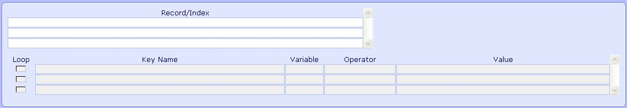
At the Record/Index prompt an F9 lookup is available to all Data Records and Indexes in the system.

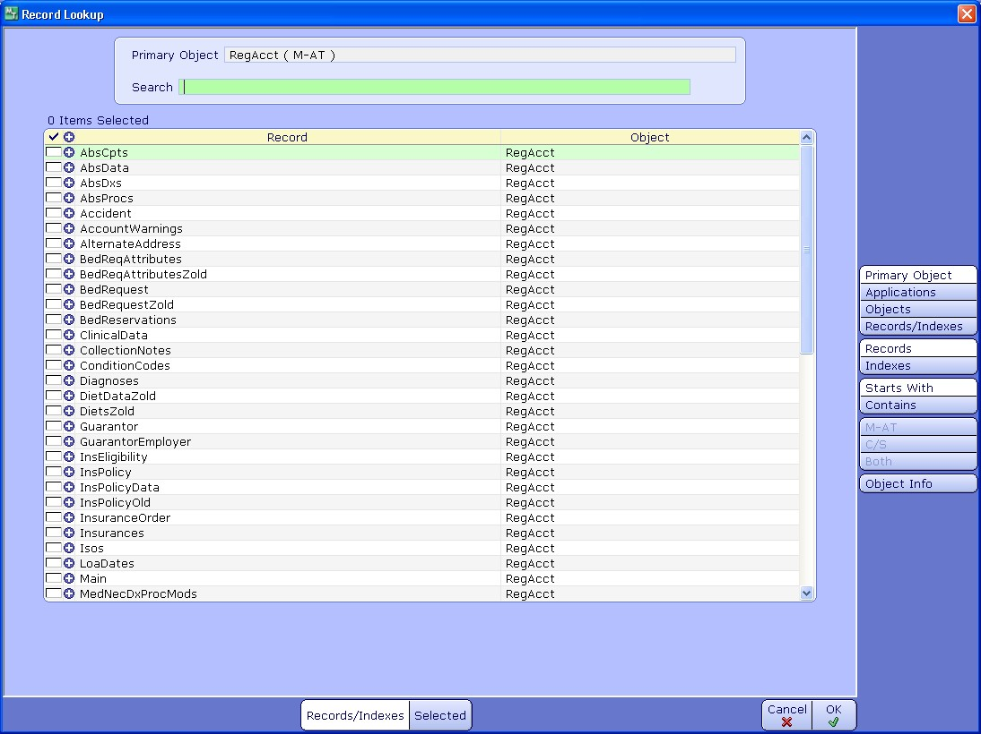

As seen above the lookup contains several useful buttons to aid in the searching of records and indexes to loop on:

- Primary Object - This will limit the lookup to only records or indexes from the object of the rule's record (defaults to this option)
- Applications - Select any application and it will display all records or indexes of that application
- Objects - Select any object and it will display all records or indexes of that object
- Records/Indexes - Searches through all records or all indexes
- Records – Limits the lookup to only data records
- Indexes – Limits the lookup to only indexes
- Starts With - Will search records or indexes starting with the entered string
- Contains - Will search within a record or index name for the entered string
- M-AT, C/S, Both - Limit the lookup to only M-AT Applications, C/S Applications, or Both
- Object Info – Will open the Object Explorer for the Object you are currently on in the lookup
- Selected - If multiple records or indexes have been selected, click on this button to view them

While in the lookup the blue circles with plus signs next to each record or index can be clicked on to display the keys of that structure.

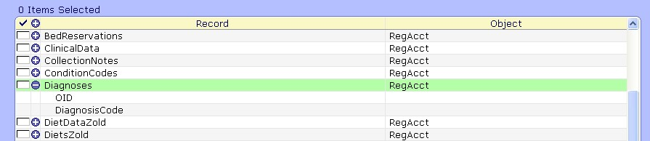

For our example we will need to loop through RegAcct.Diagnoses. To choose that record we check it off and then click on the Ok button.

After choosing our record (or index) that record will appear in the Record/Index section.

Defining Record/Index Keys and Looping Level:

The keys of the structure we are going to loop on will appear underneath the Record/Index prompt. These must be defined correctly in order for the loop to work:

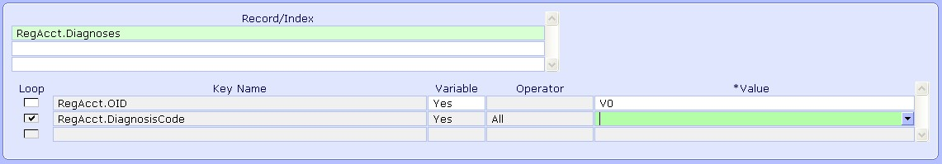

There are five columns that are used to define a record or index’s keys as well as establish the looping level. As with fields when we are subscripting, each key of the Record or Index must be defined by a variable or free text.

- Key Name – This column will contain the field names of the keys of that Record or Index
- Variable – Keep as Yes if a Variable will be used to define the key, set to No if a Free Text will be used (free text should only be used if Equals will then be used as the operator)
- Value – Set to the Variable or Free Text that will define each key
- Loop – This column defines the looping level. The Key where looping should begin should have the box checked next to it. Any key below the key that is checked will also be looped on. You will want to start a loop at the first key that is unknown. NOTE: The check box will default next to the last key so it may need to be moved up.
- Operator – Action taken on the Value. Choices are All, Equals, Starts With. For Records the Operator of All must be used at the key that has the loop check box and any key below that. The Operator of Equals is used by default on any key above the looping level.

In our example the keys of RegAcct.Diagnoses are RegAcct.OID and RegAcct.DiagnosisCode. The RegAcct.OID is stored in the variable V0 in the rule because RegAcct.Main is the record for the rule. Thus, the RegAcct.OID key is set with variable column at Yes and the Value of V0.

The RegAcct.DiagnosisCode is what is unknown and thus what we need to loop on. A patient could have more then one diagnosis code, therefore we will need to loop through each one in order to output them all. The looping level is checked off at RegAcct.DiagnosisCode because of this.

For any keys being looped on the Value should be set to a variable. This variable will act as a looping variable and will contain each value for the key as the loop progresses.

To set this up for the RegAcct.DiagnosisCode key we will keep the Variable column as Yes and at the Value column choose a variable. A lookup is available here of all the variables set up on Main screen of the rule. There we can choose a variable that we have defined already on the Main screen. Another option is to type a new free text name of a variable and create that variable on the fly.

For our example let’s type a new variable name of DX. When we type a new variable name a message like this will appear:

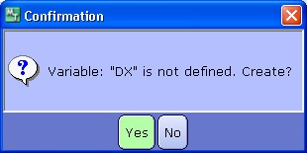

Clicking on yes will create DX as a variable and add it to the Main screen of the rule.

After following these steps the record has been set up in the following manner:

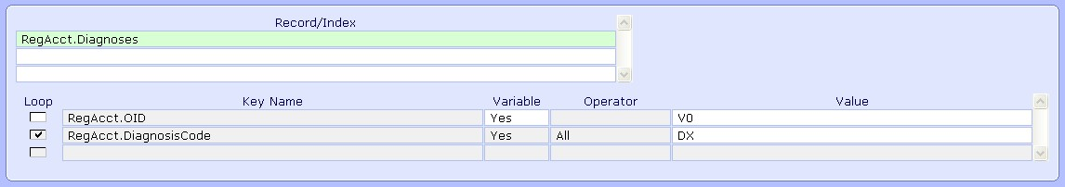

At this point we would also need to add any fields needed in the rule's logic. Since we would like to output the DiagnosisName field then that should be added to the Fields section. This field should have it's keys defaulted with values matching how we set up the keys for that field's record of RegAcct.Diagnoses.

Looping Logic:

After defining what Record/Index to loop through on the Fields screen of the rule, we must then create the actual looping logic. The loop itself is created on the Rule screen of the rule. To start the creation of the loop click on Enter Line and then the Do/If/Then option:

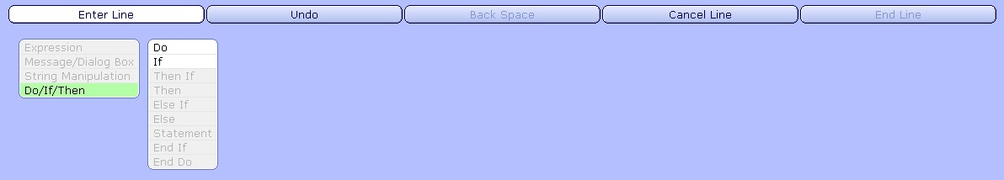
Click on Do and the following options are available. If we are setting up a loop on a data structure then we click on Record/Index. This will display a list of any records or indexes that have been added to the Record/Index section of the rule:

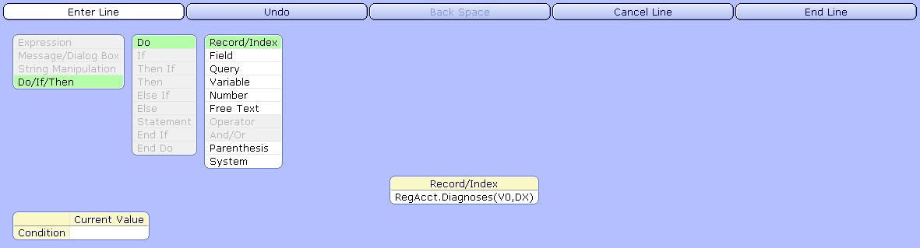

In our example we are setting up a loop on the RegAcct.Diagnoses record, which you can see is available above. After choosing the RegAcct.Diagnoses record click on End Line. NOTE: If instead we were not looping on a record or index, then we would set up a condition instead using the other prompts. We will work more with this in the next unit.

Statements/Expressions to Use Within Loops:

At this point we need to create statements or expressions that will execute each time the loop progresses until the loop stops. The options here are Then, Then If, or End Do:

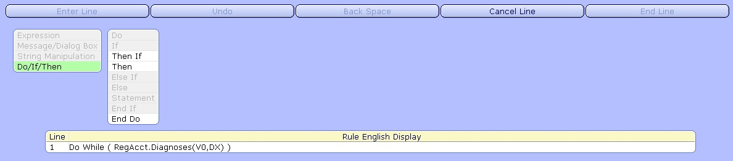

- Then – Create an Expression
- Then If – Create an If statement within the do loop
- End Do – Ends the Do condition

Depending on what you need your rule to do will influence what choice you will make here. These different choices will be illustrated in the examples within this unit.

In our example we are looking to output the diagnoses of the patient horizontally. If we are looking to output all of the diagnoses we will need to put each diagnosis into a list. To create a list of values within a loop you will need to use one of the following two options.

Join List

Will join up values such as fields, queries, or variables into a list left to right. Join List is found under the Expressions prompt:

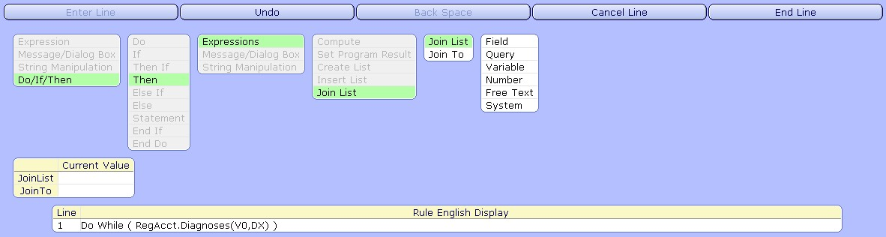

- Join List – Pick what value to add to the list
- Join To – Variable to store the list

Using the Join List option within a Do loop will continue to join up the value entered at the Join List prompt into a list as long as the Do loop executes. So, we need to create a list of all of the patient diagnoses, so the Join List value is the field RegAcct.DiagnosisName. We join this to the variable of OUT:

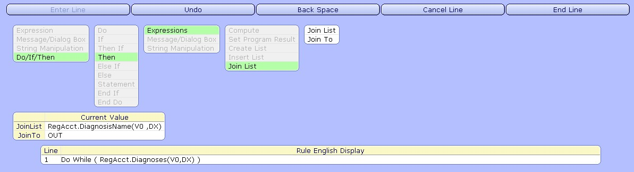

As the loop progresses each diagnosis name will be added to the list left to right.

Say out patient has three diagnoses. Those diagnoses are:

Diagnosis Code Diagnsosis Name
D1 Fever
D2 Pneumonia
D3 Infection

Here is how the list we are creating will look as the Loop Progresses using the Join List option:

{Fever} → {Fever,Pneumonia} → {Fever,Pneumonia,Infection}

Insert List

Will join up values such as fields, queries, or variables into a list right to left. Insert List can be found under the Expressions prompt and works like Join List:

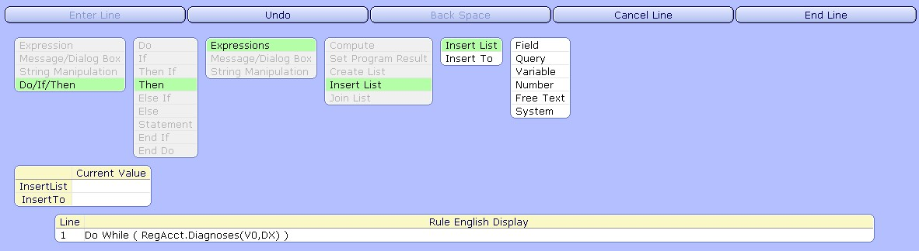

- Insert List – Pick what value to add to the list
- Insert To – Variable to store the list

As the loop progresses each diagnosis name will be added to the list right to left.

Here is how the list we are creating will look as the Loop Progresses using the Insert List option instead of Join List in the same example:

{Fever} → {Pneumonia,Fever} → {Infection,Pneumonia,Fever}

Ending Expressions and Ending the Loop:

Click on End Line after each expression created within the Loop.

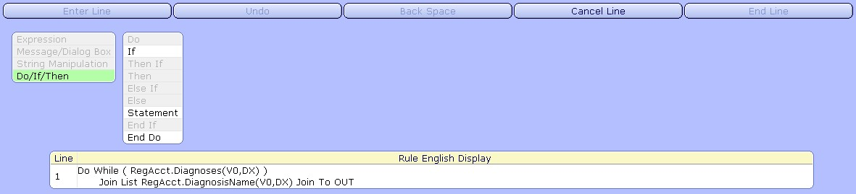

This will bring us back to options for additional expressions within the loop using the buttons of If or Statement. After creating all the expressions needed within the loop we can click on End Do to end the do loop. For our example, the Join List on RegAcct.DiagnosisName is the only expression needed. Thus, the complete loop will look like the following after clicking on the End Do button:

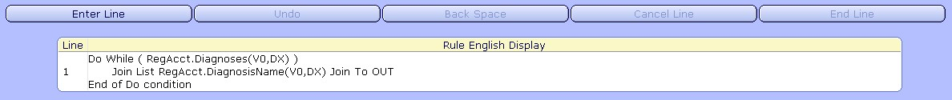

Do Loop Process:

When looping on a data structure the loop will step through each value of the keys starting at the key where the looping level is set. To illustrate this let us look at the following based on our example of looping through RegAcct.Diagnsoses. Say, our diagnosis record looks like the following. We have three patients in the system. Patient V1 has three diagnoses, patient V2 has one, and patient V3 has two.
Record: RegAcct.Diagnoses
Keys: [RegAcct.OID,DiagnosisCode]

[V1,D1]
[V1,D2]
[V1,D3]
[V2,D2]
[V3,D1]
[V3,D3]
So our first patient's registration OID is V1. They have three diagnosis codes entered on them and they are stored in this data structure. With our looping level starting at the DiagnosisCode key, here is how the do loop process will work on this patient record when the loop is executed:

- The patient's registration OID would remain constant since the operator of equals was used on that key. The RegAcct.OID would equal whatever our patient's registration OID which in this record example is V1.
- The DX looping variable starts out at Nil prior to the loop being executed
- When the loop is executed the loop will step once through this patient’s record on the DiagnoisCode key. The patient's first diagnosis of D1 would be saved in the variable DX. This defines the key of Diagnosis code thus allowing for us to access the DiagnosisName field within the loop.
- A value being returned for the variable DX makes our condition true, thus the statement(s) within the loop would be executed to create our list
- The loop would then return to the condition and step once more through the patient's record on the DiagnosisCode key. The patient's second diagnosis of D2 would be saved in the variable DX.
- The statement(s) within the loop would then be executed to create our list
- The loop would then return to the condition and step once more through the patient's record on the DiagnosisCode key. The patient's third diagnosis of D3 would be saved in the variable DX.
- The statement(s) within the loop would once again be executed.
- Finally, the loop will try the condition once more and attempt to step through the patient's record on the DiagnosisCode key. However, there are no more diagnoses for this patient so that returns a nil value which is stored in the variable DX.
- Nil is considered false so the loop fails and ends at that point.
- In summary the loop stepped though this structure three times for this patient

Outputting Values from Do Loops:

After the Do loop is complete the result of that Do loop is nil. If the Do Loop is set up as the last line of logic in the rule then the result of the rule would be nil. Thus, the loop itself should not be the last line logic if we need the rule to output a result. The Do loop should be followed with additional lines of logic in order for the rule to output the desired value(s). One common expression used with Do loops because of this is Set Program Result.

Set Program Result

Defines what variable will be output by the rule. The steps to set up the program result are:
Enter Line > Expressions > Set Program Result > (choose variable) > End Line

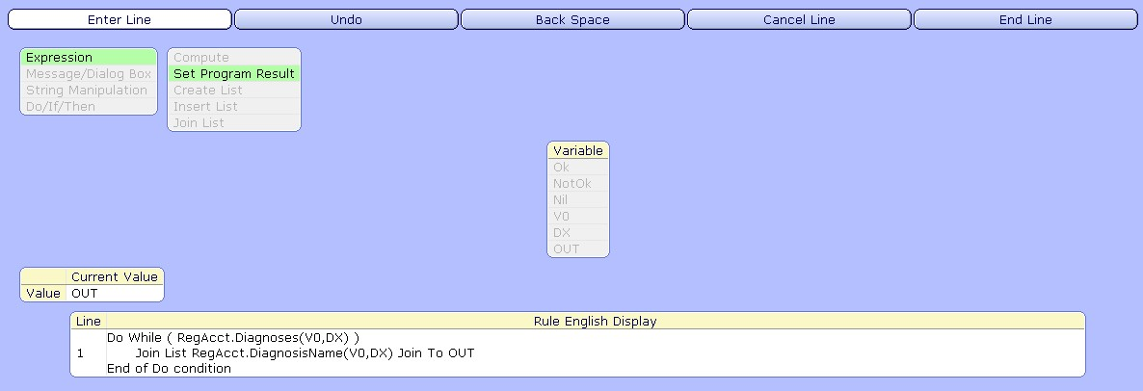

Note: The variable should contain what you want the output of the rule to be, normally this would be your last line of logic in the rule.

Other expressions could be used instead to have the rule output the desired value after a loop such as If statements or other expressions. Another option would be to use an e_variable to store a value retrieved in a loop. The e_variable could then be placed on the report to output that value.

Once the looping rule is complete then the rule can be filed.

Formatting Lists:

Using the Join List option in our rule means that we created a list that will be the output of our rule. Because of this the data type of List should be used for the c_field that uses this rule. This will allow us to format the list in the manner we want by using some additional field attributes for the list data type. Lists are stored in the following manner:
{Value1,Value2,Value3,...}

So if we were to just print a list on our report then it will include extra characters. Boxes will print in place of the brackets and commas in the list. Let's place our c_field for the diagnoses on the layout to print without changing the data type of the c_field.

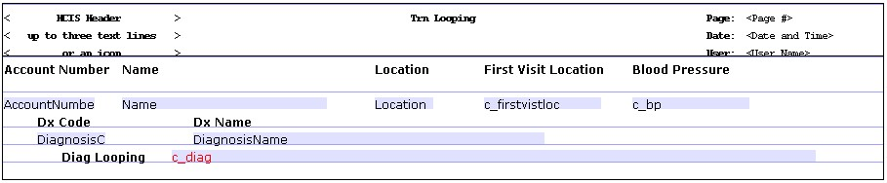
The output will look like the following:

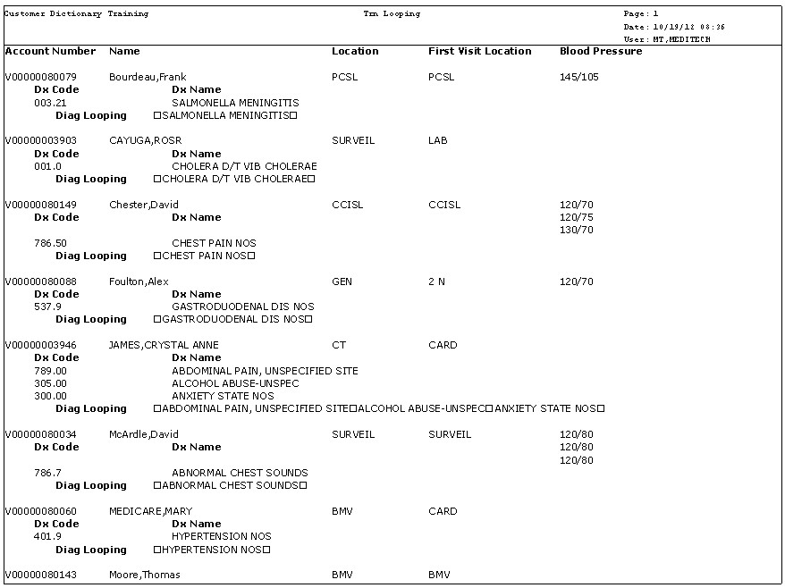
As you can see the list is in not formatted in a manner we would like. The list data type will allow us to use one or more of the following list field attributes to help format our lists or print specific values from our lists:

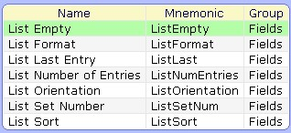

List Empty | List Empty | Allows the output format of an empty list to be defined as a tilde or the word "Empty". If not used then nothing will print. Data Type must be set to List for the field. | Tilde, Empty
List Format | List Format | Defines how the information from a list will appear. Standard will print as {1,2,3,...} and Comma Separated will print as 1,2,3,... on the output. Data type must be set to List for the field. | Standard, Comma Separated
ListLast | List Last Entry | Determines if just the last entry in a list should print. Data type must be set to List for the field. | Yes/No
ListNumEntries | List Number of Entries | Defines the maximum number of entries in a list that should print. Set this equal to 1 in order to print the first value in a list. Data type must be set to List for the field. | Positive Integer
ListOrientation | List Orientation | Defines the Orientation of the entries in a list. If Horizontal, then all the entries will appear in a single field. If Vertical, then each entry will appear on a separate line. Data type must be set to List for the field. | Horizontal, Vertical
ListSetNum | List Set Number | Defines how many entries in a list should be put together in sub-lists. Data type must be set to List for the field. | Positive Integer
ListSort | List Sort | Defines if a list should be sorted and if so in what order. | Ascending, Descending

For our example, we are trying to print our list of diagnoses horizontally. To output the diagnoses in this manner we will need two list attributes:

- List Format – Comma Separated: This will remove the boxes and separate our entries in the list by commas.
- List Orientation – Horizontal: This will print the list horizontally.

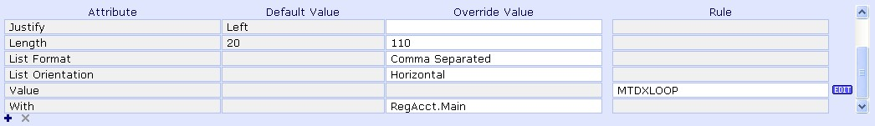

With these attributes added our output will now look like the following:
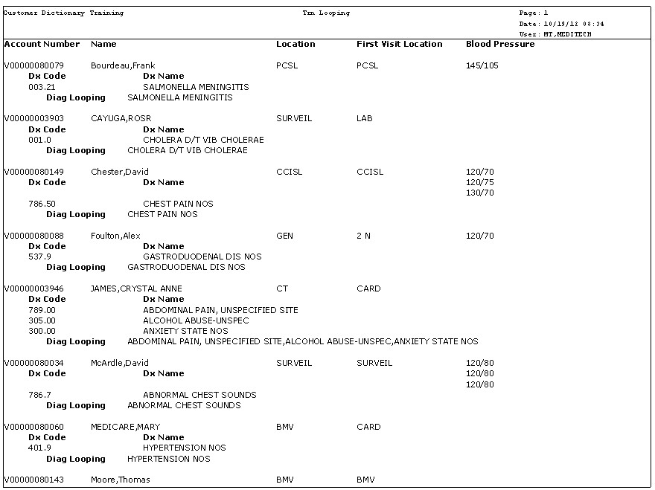

NOTE: You could change this example to output the multiple diagnosis codes in a

different sort order by using the List attributes of List Orientation set to Vertical and

List Sort Order set to either ascending or descending. Once you have a list of values

you have more control on how they are outputted.

Looping on Indexes

If we need to loop on an Index within a rule that is possible as well, and is very similar to looping on Records. Let us look at an example on how to loop on an index in a report.

Example Directive:

Say we have a report out of the object MisPerson and the detail record of Main printing provider information. The goal of this report is to also print the patient’s that this provider is responsible for. These patient's would be stored in another object such as RegAcct. They would not be stored in MisPerson which is a dictionary. One way we can do this is to loop to RegAcct through the ProviderX index to gather those patients.

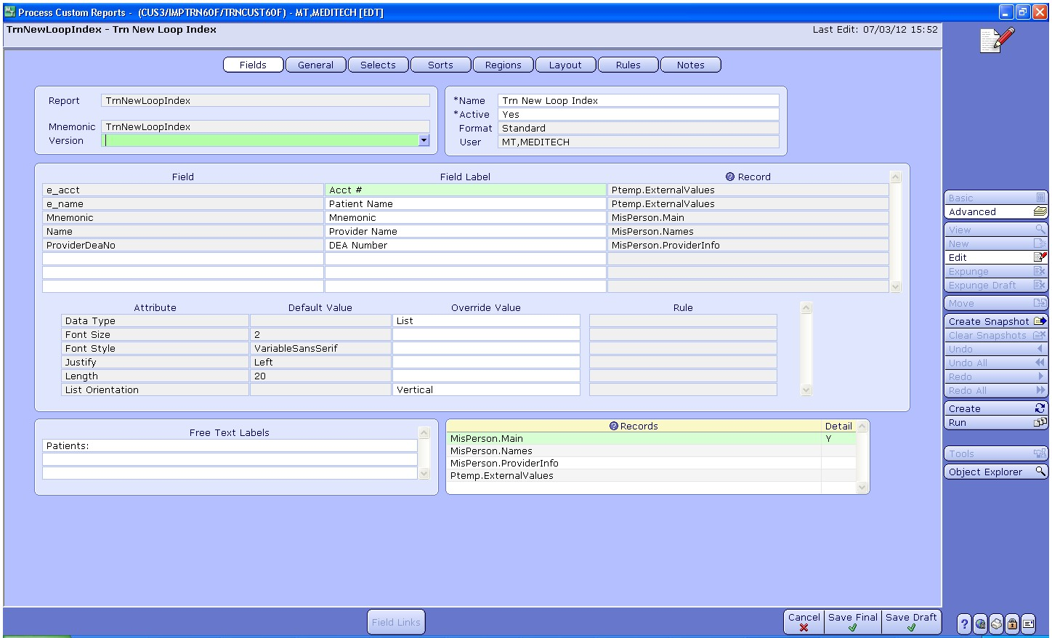

To create this loop a rule must be created. We can create this rule on a c_field or an On Entry rule. In this example lets use an On Entry rule called from the Detail region.

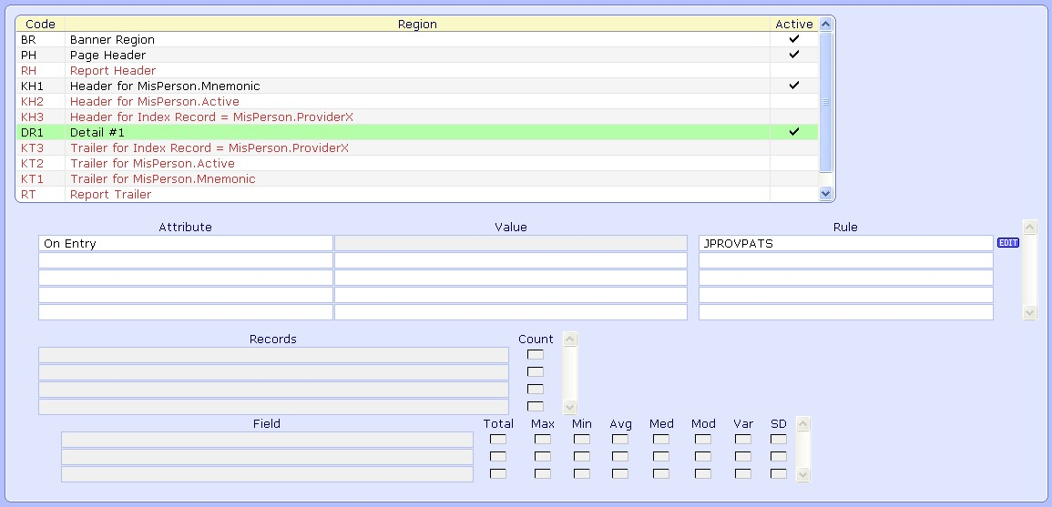

The rule will loop and get the patients for the provider and store that information in e_variables.

Main Screen of Rule:

On the Main screen of the rule add the variables that will be needed to create the rule. As stated earlier in this unit you could also type new variables needed to define keys of the record/index on the fly in the keys section of the Record/Index prompt. Since we will output our values from this rule in e_variables we will need to add a couple of e_variables to the Variable section:
- e_acct
- e_name

The following screen shot shows other variables that will be used in this rule:

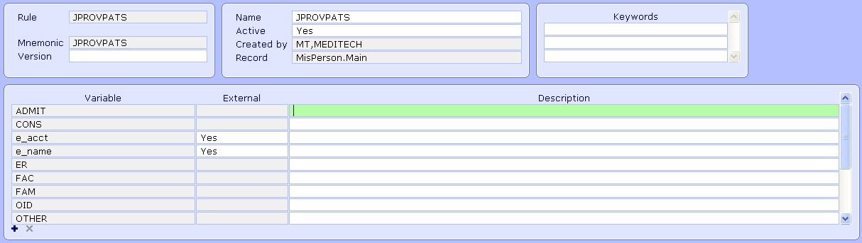

Record/Index Section of Rule:

Moving over to the Fields screen of the rule. We can do an F9 lookup at the Record/Index prompt in order to find the Index we would like to loop on.

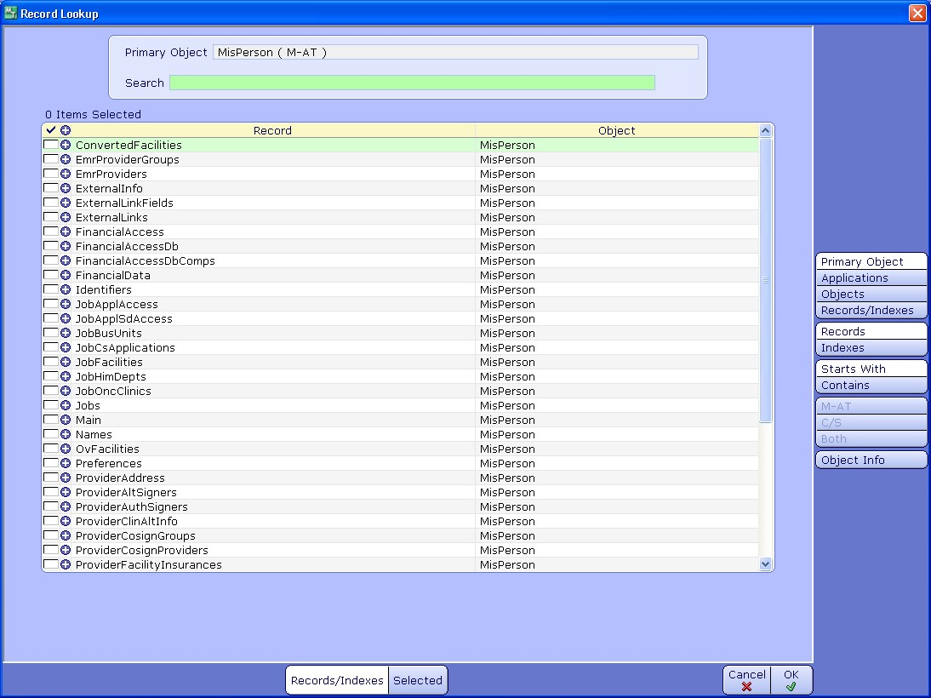

We would navigate to the object RegAcct. Since, we are looking to loop on a RegAcct index we will click on Indexes on the side bar. This then displays the indexes from RegAcct. The ProviderX index can then be selected. You can see this index in the following picture with it’s keys displayed.

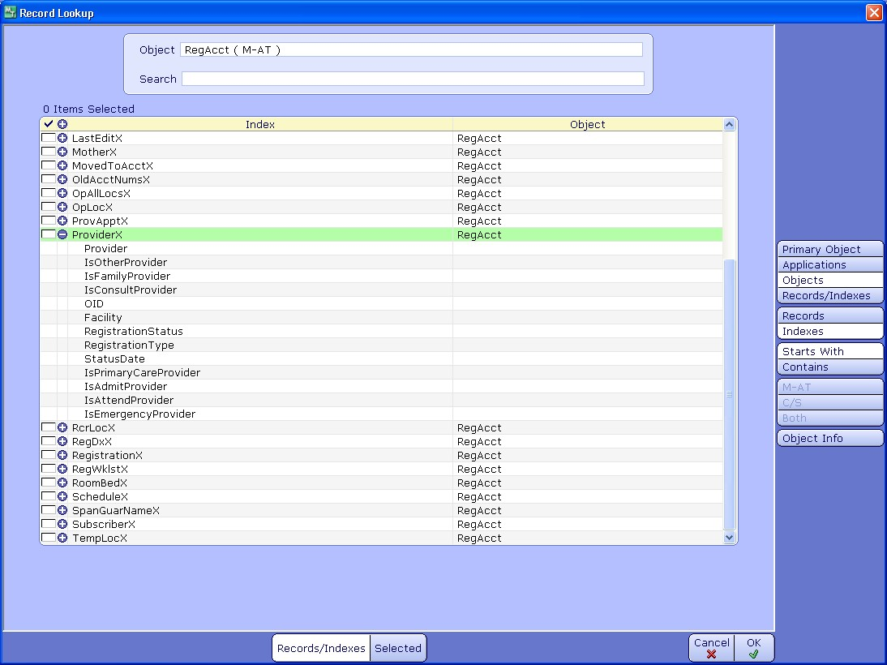

We will then check off the RegAcct.ProviderX and click Ok.

Defining Index Keys and Looping Operators:

Once the Index is selected it will appear in the Record/Index section along with it’s keys.

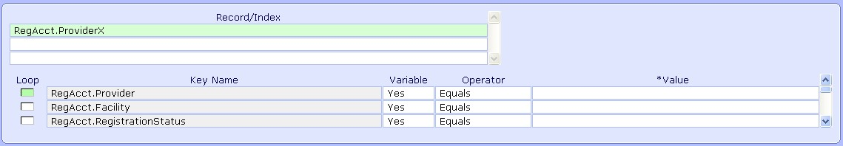

These keys must defined in the same manner that we defined the keys when looping through a record. The looping level must be defined and each key must be set up with a value. This value will either be free text or a variable.

In our example, the first key of RegAcct.Provider can be set to V0. The V0 for this rule is the MisPerson.OID which is equivalent to the RegAcct.Provider key as they both contain the provider mnemonic. We would not want to loop on provider since we have this value and only want to loop on patient's for that provider.

The second key of RegAcct.Facility is unknown if we would like to pull all patient's for a provider regardless of Facility. Thus, we check off the loop box here.

Once the looping level is checked off at RegAcct.Facility we will set that key to a variable and use the All operator. All the remaining keys can be evaluated to see if we have anything that can define them, if not they can all be set to variables and the All operator.

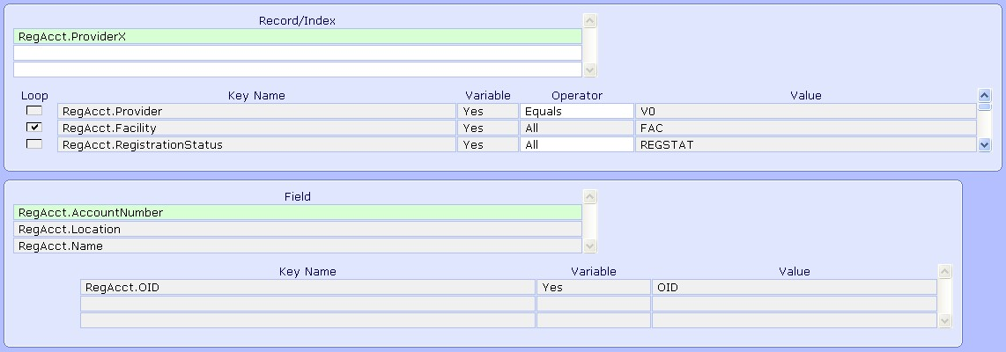

The main difference between looping on Indexes and looping on Records is that there are three choices for the looping operator for each key.

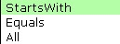
- Starts With – Will loop through all values of that key that start with the given value
- Equals – Sets a key equal to a value
- All – Loops on all values of the key

The other difference is that keys below where the looping level starts can be set to Equals or Starts With. So, we can hard code keys below where the loop starts.

In the picture above you can see the fields that we will use in this rule as well. The fields are RegAcct.AccountNumber and RegAcct.Name.

Looping Logic on Index:

From here looping on index is done in the same manner as looping on a record. On the Rule screen the Do/If/Then option is used and the index is chosen from the Record prompt. For our example, the logic should look like this:
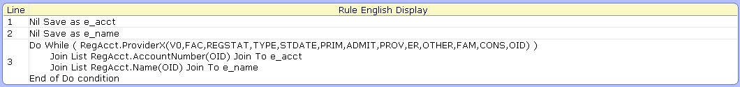

A couple of notes on this logic:

- The first two lines are used to nil our the two e_variables we are going to use of e_acct and e_name. They must be reset for each provider.
- The third line is the loop on the RegAcct.ProviderX. The loop will step through all patients stored on the RegAcct.ProviderX for the hard coded provider.
- The two statements within the loop create lists of the all of the patient names and patient account numbers for the provider
- The loop will continue until all patient's for the provider have been gone through. Once there are no patient's left that will return a nil and thus end the loop.
- The e_variables set up will be placed on the layout to output the data
- No Set Program Result is needed here since this rule is called On Entry, thus it will not matter that the result of this rule is nil

Index Example Output:

The e_variables created in the rule can then be added to the Fields section of the report and set up with the data type of List. For these e_variables use the Field Attribute of List Orientation set to Vertical. The e_variables can then be added to the layout on the Detail region.

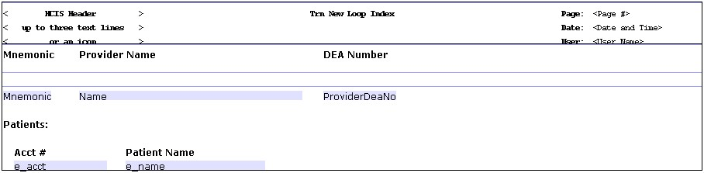

When the report is run the output will look like this, with the patient's of the provider being listed:

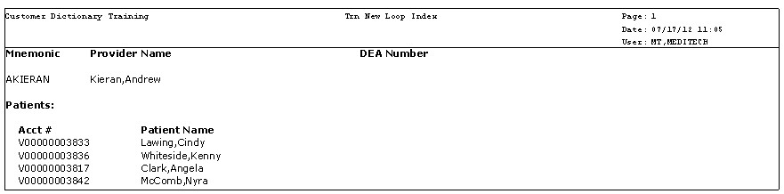

Additional Do Loop Examples

The following are some additional looping examples that provide some additional insight into how to set up loops within our reports.

Example 1:

Let's say we have a report out of the RegAcct.Main record. We would like to print the location of the patient’s first visit. To do this we will need to loop through the HimRec.VisitData record to access the field HimRec.VisitLocation from the earliest visit. To set this up in our demo report we will first need to create a c_field with a rule:

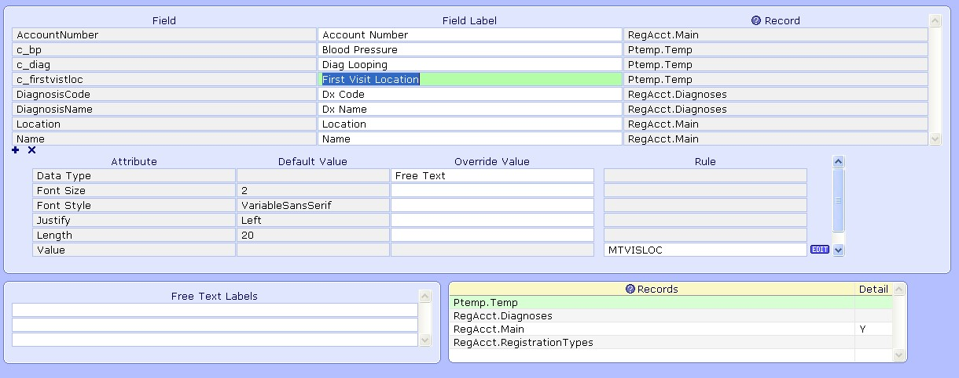

Our rule of MTVISLOC will use the following variables set up on the Main screen of the rule.

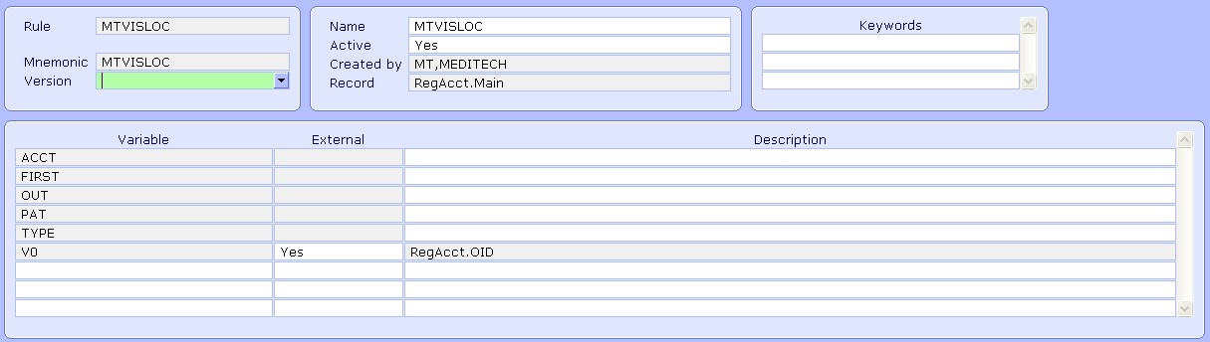

On the Fields screen of the rule the Record/Index prompt is where we will add the HimRec.VisitData record that we need to loop on. The keys of this record can be set up as follows:

- The first key of HimRec.OID is set equal to the variable of PAT. This variable will be defined by the field RegAcct.Patient in the rule's logic
- We will start the loop at the HimRec.RegAcct key, so our loop will loop through all of those values as well as through all the HimRec.VisitType values
- Those keys are set to variables and use the All operator

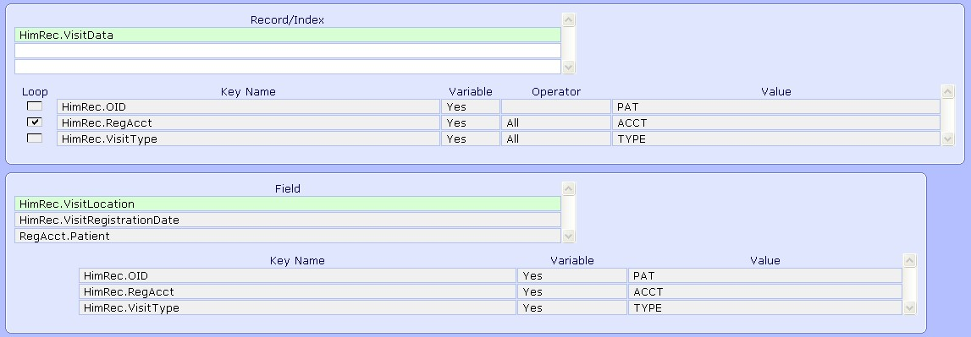

Also, seen above are the fields that will be used in our rule or HimRec.VisitLocation, HimRec.VisitRegistrationDate, and RegAcct.Patient.

The looping logic to get the first visit location of the patient is pictured here:

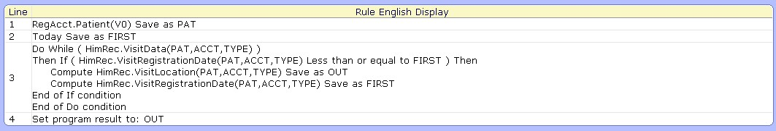

Notes on looping logic:

- The first line saves the RegAcct.Patient field as the variable PAT, this is used to define the HimRec.OID key for the HIM loop we will create
- The second line saves the system variable of today’s date as the variable of FIRST
- Line three is where the loop is done on the HimRec.VisitData record
- Within the loop there is an If statement. The If statement checks the visit registration date against the variable FIRST which starts with today’s date
- If we have found a visit date earlier then what is in the variable FIRST then we save the location of that visit in the variable OUT and also save the visit date in the variable FIRST
- The result of the rule is set to the variable OUT which should contain the first visit location

The c_field for the first location is then placed on the layout on the detail record.

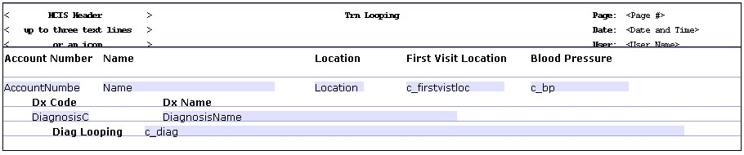

And finally the output looks like the following:

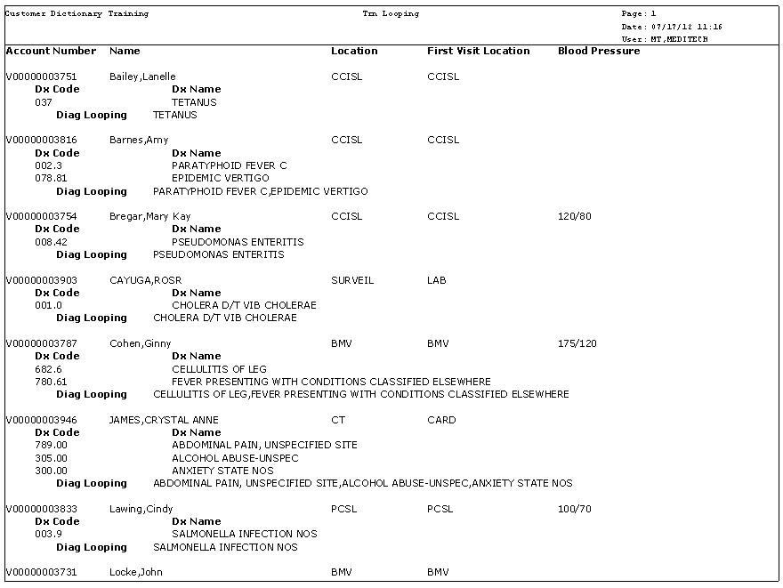

Example 2:

Do Loops can be used to get query results as well. Within the REG application there is the object RegAcctQuery. This object contains responses to queries that are set up as Account Type queries in the MIS Query Dictionary. The query responses are stored in the field RegAcctQuery.Value from the record RegAcctQuery.Results. In this example we will loop to get a query response from this record on a RegAcct report.

To do this we will create a c_field with a rule. This c_field should be set up with a Data Type of List and a List field attribute of List Orientation set to Vertical. The rule should be set up in the following manner.

On the Main screen of the rule the following variables can be set up:

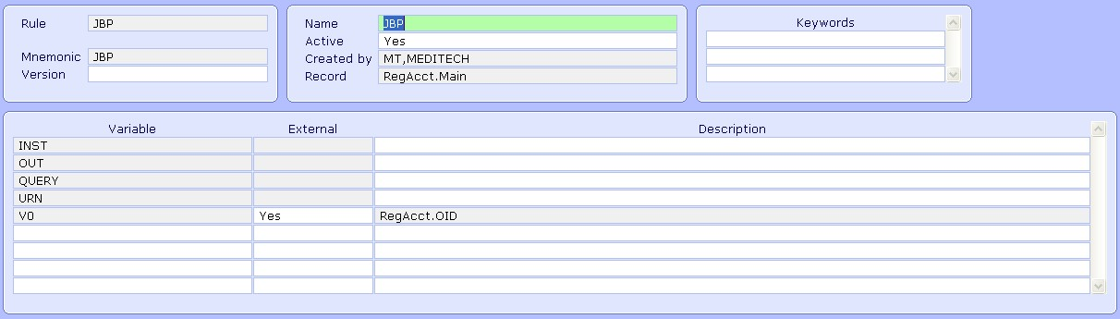
On the Fields screen of the rule the RegAcctQuery.Result record should be added to the Record/Index section. Here is how the keys from RegAcctQuery.Result should be set up:

- The first key is RegAcctQuery.OID which can be set to the variable V0
- The second key is RegAcctQuery.Query this needs to be set equal to the query mnemonic we want to pull. This is set to the variable QUERY which will be populated with the query mnemonic in the rule’s logic
- The third key of RegAcctQuery.Instance is where the loop should begin. The loop will go through all instances and the last key of RegAcctQuery.Urn

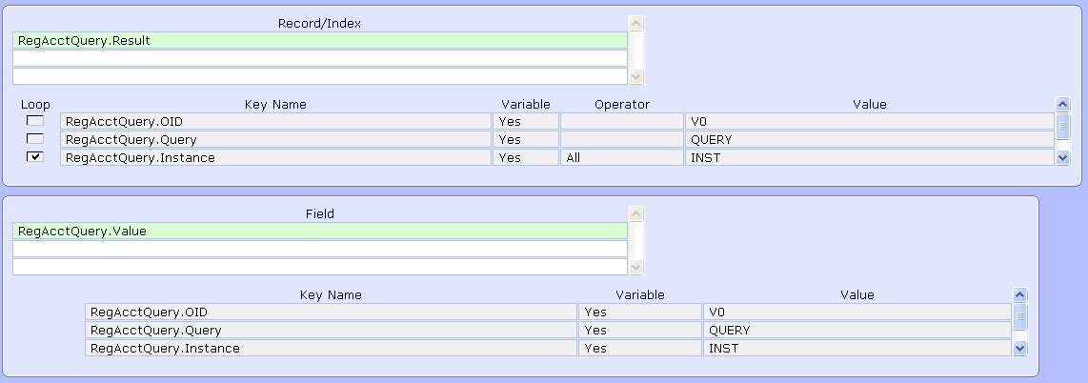

The field needed in this rule is the RegAcctQuery.Value field which can be seen added above.

The rule’s logic will look like the following:

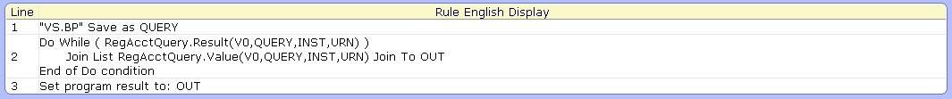

Notes on Rule’s Logic:

- Line One takes the query mnemonic we are looking for in the variable QUERY
- Line Two is the looping logic through the RegAcctQuery.Result. The statement within the loop creates a list of all responses from the RegAcctQuery.Value field in the variable OUT
- The last line sets the rule result to the variable OUT

An example of how the output would look from this rule is as follows:

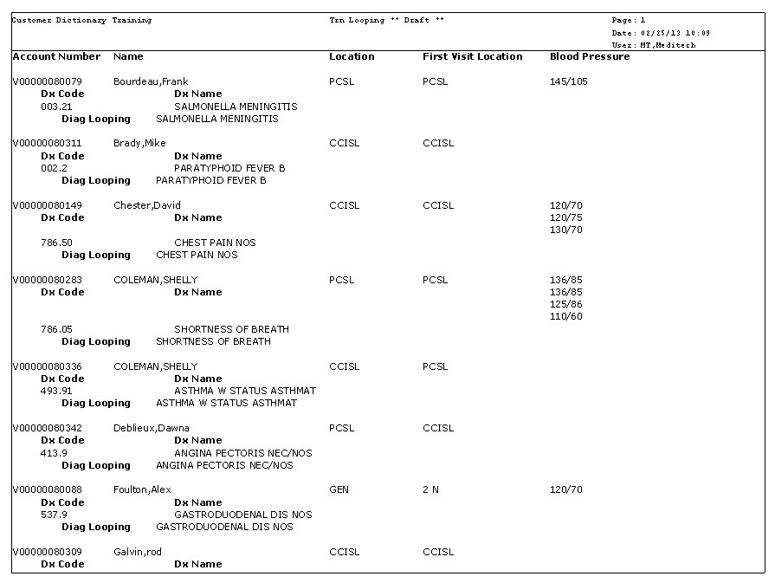
Example 3:

For our last example we are working on a report out of the object OmOrd to print ambulatory orders. On this report we are looking to print the severe allergies of each patient on the report. Allergies are stored in EmrPat.Allergies. To print these on the report we can loop over to this record.

The detail record of the report is OmOrd.Main:

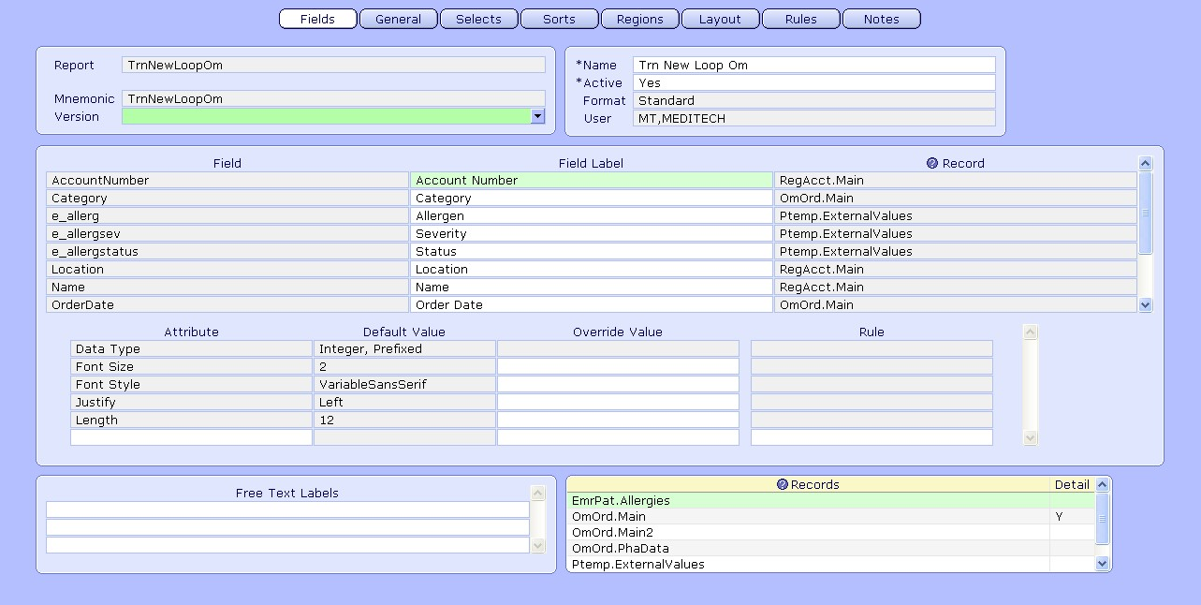

As you can see above we will be using e_variables to print out the allergy information. The e_variables will each use List as the data type and use the List Orientation attribute set to Vertical. The rule where these e_variables will be set up can be called from the On Entry attribute from the KH1 region. The KH1 region is off of the RegistrationOid sort and will print once per patient. This region will be used to print patient information, which is why the rule is called at this point.

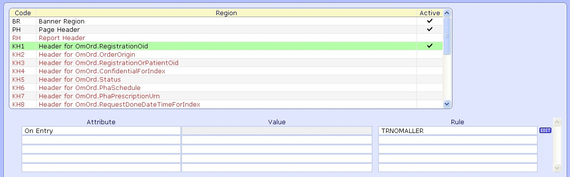

The Main screen of the rule will be set up with the variables needed for the rule. Three e_variables are going to be used to output the allergy information.

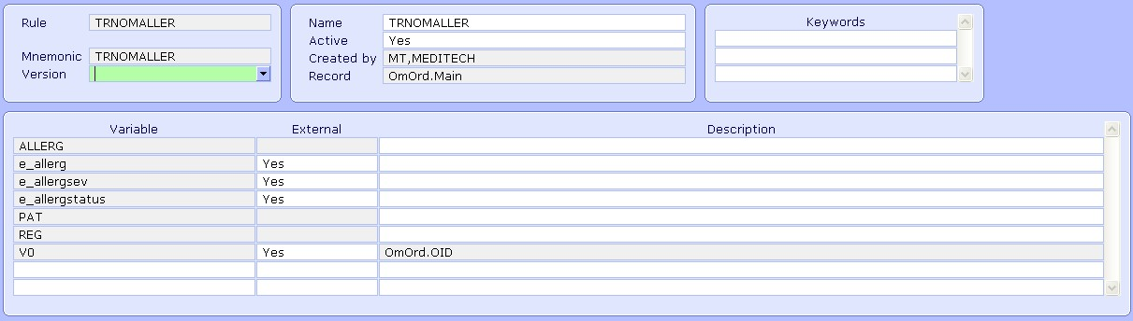

The record we will loop through is EmrPat.Allergies. This record's keys can be set up as follows:

- The EmrPat.OID key is equivalent to the Patient OID which is stored in the field Patient from RegAcct. This value will be defined in the variable PAT
- The second key of EmrPat.Allergen is where the loop needs to begin, so the loop check mark is set here
- The Allergen key is set to a variable and uses the All operator

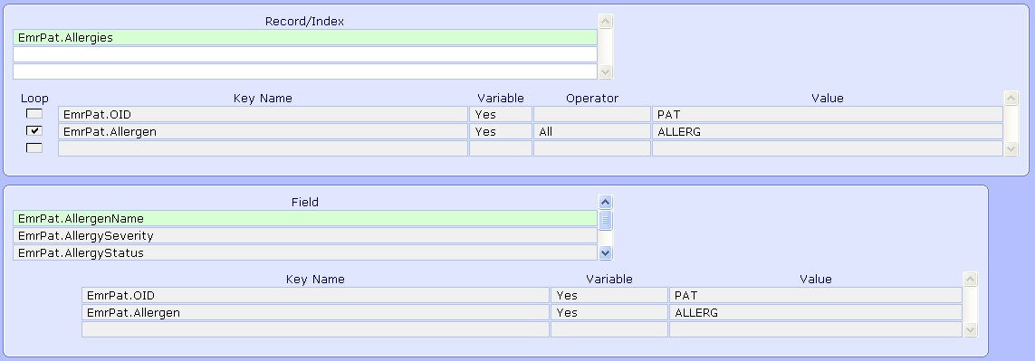

As seen above, we are using several fields in this rule as well. The three allergy fields that we are going to output are AllergenName, AllergenSeverity, and AllergyStatus. The field RegAcct.Patient is also needed. This is used to define the EmrPat.OID key. Since, we are starting in OmOrd we also need to subcript to the RegAcct.Patient field using the OmOrd.RegistrationOid field which defines the RegAcct.OID key.

The rules logic can then be set up like the following:
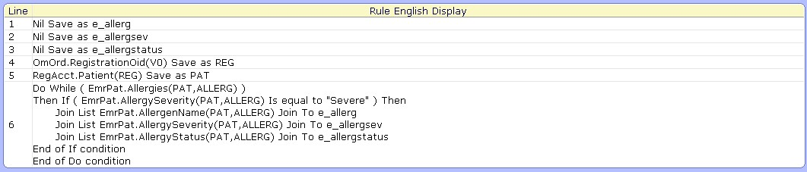

Notes on Rule’s logic:

- The first three lines nil out the e_variables that will be used
- The fourth line saves the field OmOrd.RegistrationOid as the variable REG in order to define the RegAcct.OID key
- The fifth line saves the field RegAcct.Patient as the variable PAT in order to define the EmrPat.OID key
- Line six is where the looping is set up. Within the loop an If statement is used to check if Allergies are Severe. If the allergy is severe then we create lists of the AllergenName, AllergySeverity, and AllergyStatus and store them in the three different e_variables.
- If the allergy was not severe then it is not stored and thus will not be output

The e_variables created should then be added to the Fields section of the report and then placed on the KH1 region of the report. All fields from OmOrd are placed on the Detail region while all other patient related fields should be on the KH1 region.

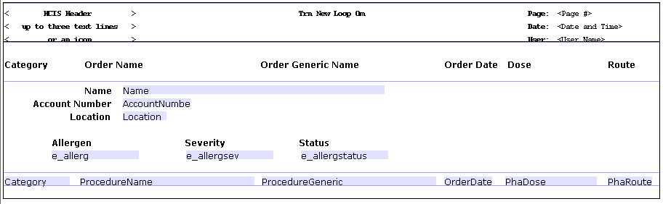

A sample of the output of the report can be seen below:

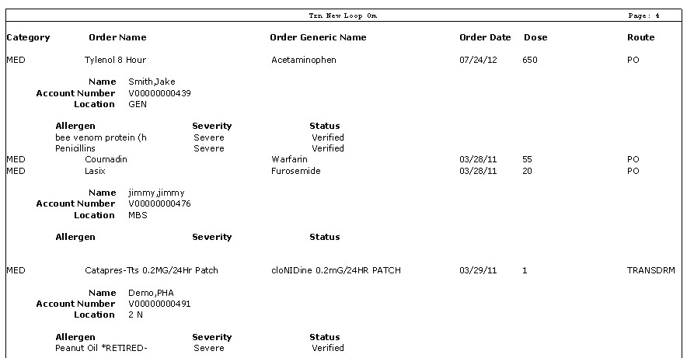
Additional Reading:

The following are some additional examples involving do loops:

- Printing PCS Queries
https://www.meditech.com/meditechmagazine/pages/0612_npr.htm
- Looping on Indexes
https://www.meditech.com/meditechmagazine/pages/0311_npr3.htm
- Looping through EdmActivity to Calculate ED Turn Around Times
(KB # 40076)
https://www.meditech.com/kb/Custform.ASP?urn=40076
- Print Intervention Text for Order on a Report in OmOrd
https://www.meditech.com/kb/Custform.ASP?urn=44748

Report Designer Workshop: Unit 20 Do Loops

Directive
For this Workshop create a new report out of the object OmOrd to print order information. The detail record of this report should be OmOrd.Main. This report will also include patient information from RegAcct. Furthermore, we will want to create a c_field with a rule to print a patient's active problems, which are found in the record EmrPat.Problems. This rule will need to loop through the EmrPat.Problems record, and join up a list of all of the patient's active problems. This list should be output vertically on the report output in a header key region off of a OmOrd.RegistrationOid sort field. All other patient fields should also be placed in that region, while all OmOrd fields should be placed on the Detail region.

To create this report the following steps can be followed. These steps have been broken down by pages:

Fields
- Create a new report
- At the fields section add the following fields from OmOrd to the report:
- Category
- OrderNumber
- ProcedureName
- StartDateTime
- Add additional fields to the report from RegAcct including:
- AccountNumber
- Name
- Location
- Create a c_field called c_probs. Set this c_field up with the Data Type of List, and the additional List field attribute of List Orientation set to vertical.
- Set the With attribute for this c_probs field to RegAcct.Main. Create a new rule for this c_field using the following steps.

Rule - General
- You will need to add three internal variables here of OUT, PAT, and PROB

Rule - Fields
- Do a lookup at the Record/Index section and navigate to the record EmrPat.Problems, check off this record and click Ok
- Set the first key of EmrPat.OID to the variable PAT
- Set the second key of EmrPat.Problem to the variable PROB. Make sure the loop check box is marked at this key.
- Add fields of EmrPat.Problem status and RegAcct.Patient

(continued next page)

Rule - Rule
- Build the first line of the rule to save the field RegAcct.Patient as the variable PAT
- The second line will build the Do loop to loop through EmrPat.Problems. Within the Do loop there should be an If statement. The If statement should check if the ProblemStatus Is Not Equal to Inactive. If so, then join up a list of the variable PROB in the variable OUT. Follow these steps:

Enter Line > Do/If/Then > Do > Record > EmrPat.Problems > End Line
Then If > Field > EmrPat.ProblemStatus > Operator > Is Not Equal To > Free Text
> Inactive > End Line
Then > Expressions > Join List > Join List > Variable > PROB > Join To > OUT
End If
End Do

- The third and final line of the rule should set the program result of the rule to the variable OUT
- Save the rule as final.

Selects
- Add the Field OmOrd.StartDateTime as a select field. Use the Operator of In Range to select on a date range of orders.
- Add the index of OmOrd.StartX to the index section.

Sorts
- Move the OmOrd.RegistrationOid field up to be the first sort of the report.

Regions
- Add a Page Header Region
- Add a KH1 Region for OmOrd.RegistrationOid. Add a Page Break attribute to this region set to Yes.

Layout
- Use the Auto Format button and add all fields and labels to the layout.
- Drag the RegAcct fields and the c_probs field up into the KH1 region
- Format the report the way you like and click on Create Report to save
- Run the report

